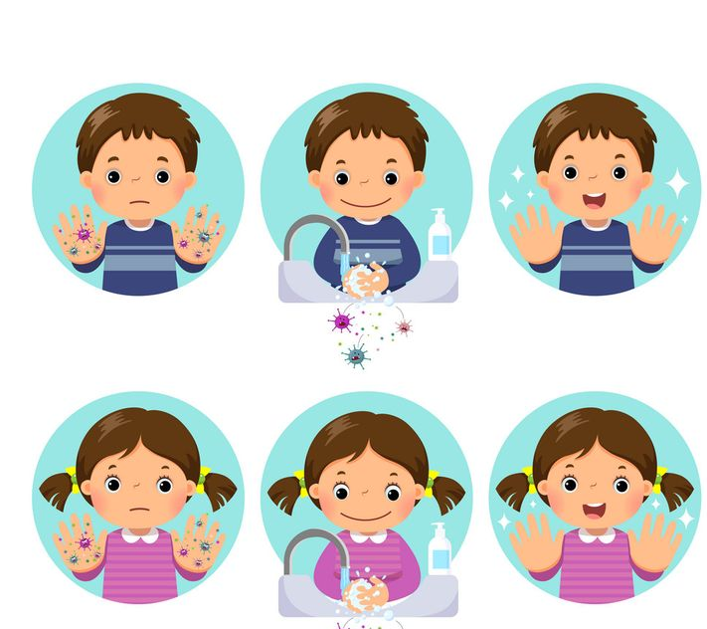

Public health measures in place on 5th January 2022. Follow links for more up to date information.
From Department of the Taoiseach; Department of Health
Published on 28 May 2021
Last updated on 31 December 2021

- 1. Measures in place
- 2. Sectoral guidance
- 3. See the latest COVID-19 case numbers
The public health advice is that the future trajectory remains uncertain. The steps everyone can take to help reduce the spread of the virus are:
1. If you have any symptoms of COVID-19 then stay at home. If you are aged between 4-39 then you should take an antigen test. If you get a positive result then you should book a PCR test. For those aged 3 or under or 40 or above - you should still book a PCR test as soon as you notice symptoms.
2. Get your booster vaccine if you are eligible – being vaccinated offers good protection against severe illness and hospitalisation and lowers the risk to you and others.
When it is time for your booster vaccination, you will get a text message from the HSE to attend one of their scheduled clinics, or you may attend a designated walk-in vaccination clinic for your age group.
Vaccination centres and GPs continue to offer appointments to the priority groups identified by NIAC and people can also avail of walk-in clinics at vaccination centres and through pharmacies which you can see on the HSE website.
Check the HSE website and the HSE Twitter feed which will continue to provide full updates.
If you are offered a booster appointment at a scheduled clinic, prioritise it.
3. Remember to R.S.V.P. before you meet up with people – think of the Risk, Symptoms, Venue, People – go to gov.ie/riskaware to help assess the risk involved in any activities you have planned and the measures you can take to minimise your risk.
4. Government advice is that everyone should take account of their overall health, their vaccine status, and the spread of Omicron in other countries before they decide to travel.
To get further information before you travel, go to gov.ie/travel.

Measures in place

Family and social gatherings
Visits to private homes should be kept to a maximum of 3 other households (that is, 4 households in total).
Recognising the need for flexibility depending on individual circumstances, people should limit their contacts throughout the period.
In noting this advice, the government acknowledged that in assessing how to apply flexibility, households will likely have regard to the re-formation of family households over the Christmas period and those who belong to household support bubbles.
In particular, it is recognised there are specific days and dates (25, 26 and 31 December) in the calendar which are important social and cultural occasions where families will likely choose to come together in larger household numbers.

Guidance for children
Parents should aim to reduce socialisation indoors in respect of children aged 12 and younger.
Parents are being asked to prioritise their children’s activities by:
- minimising indoor community gatherings and indoor mixed household gatherings
- reducing the risk of exposure to the virus by opting for outdoor activities instead of indoor
- reducing the number of children involved in any particular activity
Subject to review in mid-February 2022, the wearing of face masks/coverings is recommended for children:
- aged 9 years and over on public transport, in retail and other indoor public settings as currently required for those aged 13 and over
- in third class and above in primary school (guidance on this has been issued by the Department of Education)

Guidance for close contacts
For further information on what to do if you are a close contact, visit the HSE’s website.
You can also see a quick guide to isolation on the HPSC's website.

Religious services
Religious services can proceed without capacity limits but with all other protective measures remaining in place.

EU Digital COVID Certificate
An EU Digital COVID Certificate (COVID pass) (vaccine or recovery certificate) is required for:
- indoor hospitality and events
- cinemas and theatres
- gyms and leisure centres (excluding access to swimming pools or standalone swimming pool facilities)
- hotel bars and restaurants (that is, removing exemption for residents)
There are exemptions for those for whom a hotel setting is their permanent residence (for example, those in emergency accommodation or other state-supported accommodation arrangements).

